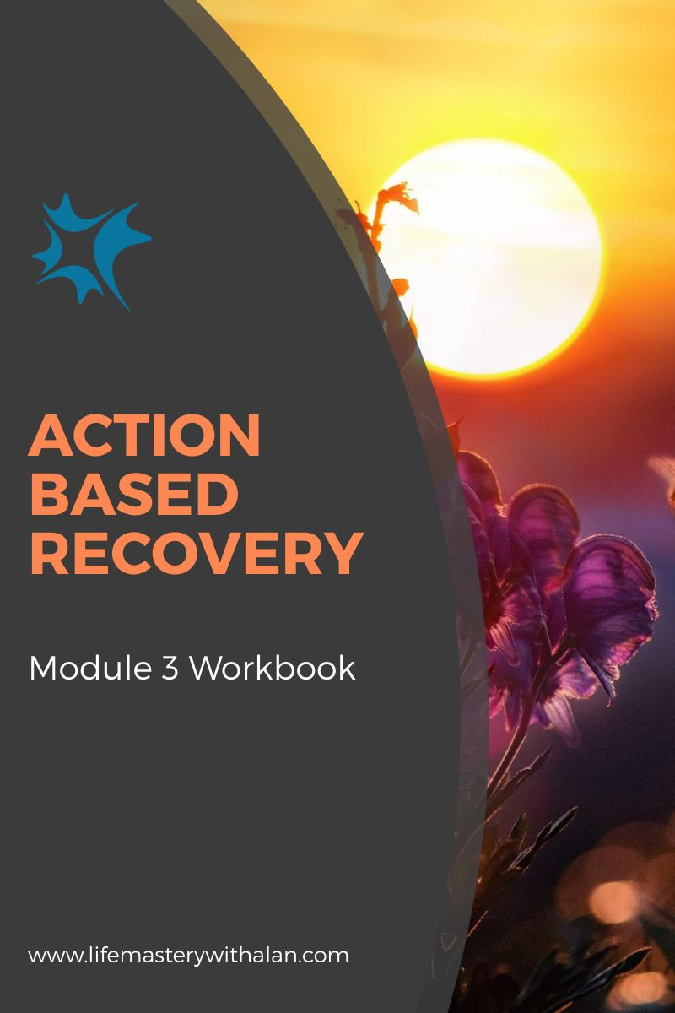
Table of Contents
Introduction 2
What Do You Want to Change? 3
Areas in my Life That Could Use Improvement: 3
Challenges I Face in Those Areas: 4
Ways This Workbook Can Help Me: 4
What Are Your Affirmative Habits? 5
Affirmative Habits I Already Have in my Life: 5
How I Have Kept These Habits: 5
How These Habits Have Benefitted me: 6
Your Small Changes Template 7
Explaining the Template: 7
Conclusion 18

Introduction

The idea of changing or building new habits can be overwhelming.

Maybe you do not know where to start. Perhaps you are nervous about making big changes. You may have tried before and were disappointed with your results.

Keeping it simple will give you the best chance of achieving your goals.

Instead of focusing on the entire picture you can choose a couple of small changes.

Embrace the type of small changes that are easy to start and sustain. Through regular repetition these changes can provide impressive results.

Welcome to the world of…. Small Changes!

This workbook is designed to become your template for creating small changes that can end up producing life-changing results.

What Do You Want to Change?

The best place to start when you are trying to create new affirmative habits, even if they are small, is to figure out what you want to change.

When you know what you want to change then you know why you want to change.
Having that motivation is one of the most powerful steps you can take to ensure you can sustain your new habits.

Areas in my Life That Could Use Improvement:

Challenges I Face in Those Areas:

Ways This Workbook Can Help Me:

What Are Your Affirmative Habits?

Even though you might not recognize it at times you do have affirmative habits.
Take some time to reflect on the affirmative habits you already have. This will help you focus on areas you want to change later in this workbook.

It is important to remember that recognizing what you are doing well can improve your self-esteem.

Affirmative Habits I Already Have in my Life:

How I Have Kept These Habits:

How These Habits Have Benefitted me:

Now that you have spent some time reflecting on your affirmative habits you know the areas of your life that you want to focus on to change.

You have reaffirmed that you do indeed have the power to sustain affirmative habits.

You also know exactly how these habits have benefited your life.

I bet you are ready to start some small changes now. I will now introduce you to the Small Changes Template.

Your Small Changes Template

In this section you will start building your new small changes! I have included a number of these templates for you to use and you are not limited by the number.

Copy and paste, or write out on your own, these templates if you need even more room than I provide.

NOTE: Keep in mind these new habits should be small and easy to add into your daily life. The habit probably will not change your life overnight as it is designed to make a difference when practiced regularly over time.

Explaining the Template:

Area of Life to Change – Simply choose what area of your life you want to change (e.g., financial)

Small Changes That Can Help – Choose a small and easy habit that can make a big difference in the long run (e.g., I will start saving my loose change)

Potential Obstacles I May Face – List any problems that might occur (e.g., I like using my change for a morning coffee)

How I Will Manage Those Obstacles – List the ways you could manage those obstacles (e.g., I will start making coffee at home).

Start Date – When you will start? Today?
Frequency- How often you will practice the new habit? Daily is best!
Check In Date – When you will check in to see how things are going? In 30 days?
Area of Life to Focus On:_______________________________________________
___________________________________________________________________

Small Changes That Can Help:_________________________________________
___________________________________________________________________
___________________________________________________________________
Potential Obstacles I May Face:
1.
2.
3.

How I Will Manage Those Obstacles:

1.
2.
3.

Start Date: ______________________________
Frequency: ______________________________
Check In Date: ____________________________

Area of Life to Focus On:_______________________________________________
___________________________________________________________________

Small Changes That Can Help:_________________________________________
___________________________________________________________________
___________________________________________________________________
Potential Obstacles I May Face:
1.
2.
3.

How I Will Manage Those Obstacles:

1.
2.
3.

Start Date: ______________________________
Frequency: ______________________________
Check In Date: ____________________________

Area of Life to Focus On:_______________________________________________
___________________________________________________________________

Small Changes That Can Help:_________________________________________
___________________________________________________________________
___________________________________________________________________
Potential Obstacles I May Face:
1.
2.
3.

How I Will Manage Those Obstacles:

1.
2.
3.

Start Date: ______________________________
Frequency: ______________________________
Check In Date: ____________________________

Area of Life to Focus On:_______________________________________________
___________________________________________________________________

Small Changes That Can Help:_________________________________________
___________________________________________________________________
___________________________________________________________________
Potential Obstacles I May Face:
1.
2.
3.

How I Will Manage Those Obstacles:

1.
2.
3.

Start Date: ______________________________
Frequency: ______________________________
Check In Date: ____________________________

Area of Life to Focus On:_______________________________________________
___________________________________________________________________

Small Changes That Can Help:_________________________________________
___________________________________________________________________
___________________________________________________________________
Potential Obstacles I May Face:
1.
2.
3.

How I Will Manage Those Obstacles:

1.
2.
3.

Start Date: ______________________________
Frequency: ______________________________
Check In Date: ____________________________

Area of Life to Focus On:_______________________________________________
___________________________________________________________________

Small Changes That Can Help:_________________________________________
___________________________________________________________________
___________________________________________________________________
Potential Obstacles I May Face:
1.
2.
3.

How I Will Manage Those Obstacles:

1.
2.
3.

Start Date: ______________________________
Frequency: ______________________________
Check In Date: ____________________________

Area of Life to Focus On:_______________________________________________
___________________________________________________________________

Small Changes That Can Help:_________________________________________
___________________________________________________________________
___________________________________________________________________
Potential Obstacles I May Face:
1.
2.
3.

How I Will Manage Those Obstacles:

1.
2.
3.

Start Date: ______________________________
Frequency: ______________________________
Check In Date: ____________________________

Area of Life to Focus On:_______________________________________________
___________________________________________________________________

Small Changes That Can Help:_________________________________________
___________________________________________________________________
___________________________________________________________________
Potential Obstacles I May Face:
1.
2.
3.

How I Will Manage Those Obstacles:

1.
2.
3.

Start Date: ______________________________
Frequency: ______________________________
Check In Date: ____________________________

Area of Life to Focus On:_______________________________________________
___________________________________________________________________

Small Changes That Can Help:_________________________________________
___________________________________________________________________
___________________________________________________________________
Potential Obstacles I May Face:
1.
2.
3.

How I Will Manage Those Obstacles:

1.
2.
3.

Start Date: ______________________________
Frequency: ______________________________
Check In Date: ____________________________

Area of Life to Focus On:_______________________________________________
___________________________________________________________________

Small Changes That Can Help:_________________________________________
___________________________________________________________________
___________________________________________________________________
Potential Obstacles I May Face:
1.
2.
3.

How I Will Manage Those Obstacles:

1.
2.
3.

Start Date: ______________________________
Frequency: ______________________________
Check In Date: ____________________________

Conclusion

I sincerely hope this workbook will help you enact long-lasting affirmative change.

After you worked through it fully you will:

- Know what you need to work on
- Know what you are already doing well
- Have a list of new small changes you can start doing right away

Establishing these small new habits can be much easier than you think. You may even wonder why you did not start sooner.

Wishing you the best always!
Alan Simberg, Ph.D.

