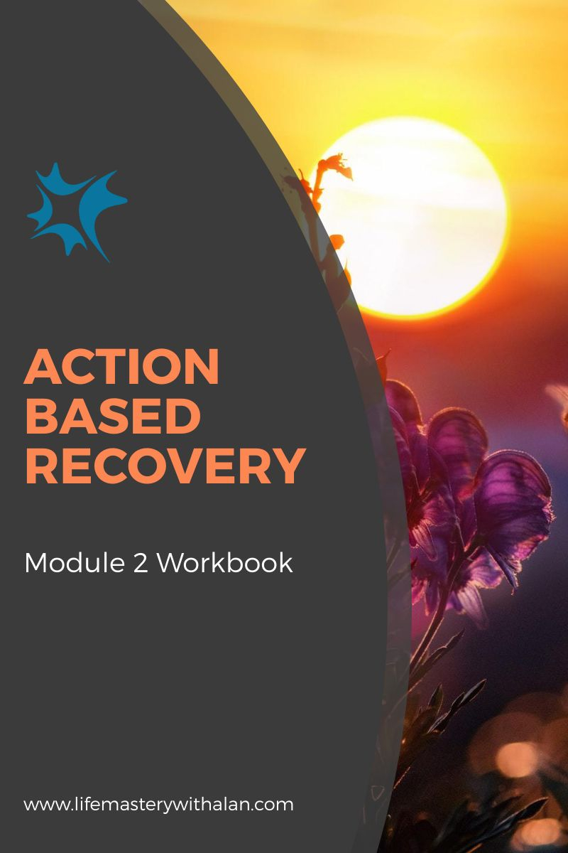
TABLE OF CONTENTS
INTRODUCTION 2
Your Attitude
The CounterProductive Attitude 3
EXERCISE 1) 4
EXERCISE 2) 5
The Affirmative Attitude 6
EXERCISE 3) 7
The 7 Point Attitude Adjustment 8
Think Affirmative Thoughts 9
EXERCISE 4) 10
Create Your Happiness 11
EXERCISE 5) 12
Boost Your Personal Energy 13
EXERCISE 6) 14
Believe in Yourself 15
EXERCISE 7) 15
Worry Less 17
EXERCISE 8) 17
Conquer Your Fears 19
EXERCISE 9 19
Overcome Counterproductivity in Others 21
EXERCISE 10) 21
CONCLUSION 23

INTRODUCTION
Your Attitude
Every person on this earth has their unique individual array of emotions that reveal themselves in the form of distinct attitudes. How you manage your emotions contributes to your overall mood and perspective of life. The consistency and degree to which you manage your emotions will affect your experiences during recovery. And this, in turn, can help you to have ongoing consistency and peace of mind during your recovery.
The first step to any change in your life is to identify your attitude. Once you are aware of how you are projecting your emotions you will be in a better position to change them.
Completing this workbook will help you to identify and adjust your attitude. You can then lead a much more fulfilling life and have ongoing recovery, increased happiness, flourishing relationships and enhanced performance in your career.

The Counterproductive Attitude
A counterproductive attitude can be present in a variety of different ways so it can be difficult to recognize. Focusing your awareness on your thoughts and what others say will help you notice them.
People who are living every day with a counterproductive attitude tend to experience a depressed state of mind, disinterest in attending social events, fragmented relationships with those closest to you and an ever-present worry that can be incredibly debilitating
Your counterproductive attitude makes it harder to problem-solve, creates imaginary scenarios that are not necessarily real and prevents you from challenging yourself to grow.
Here are some ways that a counterproductive attitude manifests itself.
- Fear of failure
- Pessimism
- Blaming others
- Assuming the worst
- Self-doubt

EXERCISE 1)
Read the explanation of some possible effects of a counterproductive in the main program under the heading ‘The Damage of Counterproductive Attitudes and Thoughts.’ Now rate and think about how any of your counterproductive attitudes may be affecting your recovery, happiness and success.
Complete the table below. Rate each counterproductive result for how it affects your life.
Result of Counterproductivity | The effect on your life (0= no effect, 9=maximum effect)
 | 0 | 1 | 2 | 3 | 4 | 5 | 6 | 7 | 8 | 9
Fear of failure
Pessimism
Blaming others
Assuming the worst
Self-doubt

EXERCISE 2)
Have you recently experienced counter productivity about something or someone in your life?
What was the result of experiencing it? Is the result already given above or something different?
Who or what did it hurt? Was it your recovery? Was it someone you know? Was it your bank balance?
Think about those questions and then complete the table below. Continue on another sheet of paper if necessary.
Over what have you recently experienced counter productivity? | What was the result of experiencing it? | Who or what was hurt by it?
The Affirmative Attitude
An affirmative attitude enhances your life in ways that you may never have imagined because it does not only affect you. When you possess optimism, drive, resilience and all the other factions of an affirmative attitude you will become happier and others around you will tap into that energy.
A counterproductive attitude forms when you consistently allow yourself to have counterproductive thoughts. An affirmative attitude starts when you make a conscious effort to replace those counterproductive thoughts with affirmative ones. You are able to make this change by consciously replacing the counterproductive thoughts with affirmative ones.
Some of the benefits an affirmative attitude can provide include:
- Less stress
- Stronger immune system
- More happiness
- More open-minded
- Better determination
- Increased kindness
- More resilient
- A better understanding of others

EXERCISE 3)
Look at your answers to Exercise 2 above.
Think about how you could have replaced the counterproductive experiences you identified in the previous exercise with affirmative ones?
Think about that question and your answers in Exercise 2). Then complete the table below:
What was the counterproductive event? | How could you have responded differently to the event and added something affirmative to it? | What benefits would you see resulting from an affirmative response?
The 7 Point Attitude Adjustment
Now you are going to think about the 7 steps that have proven to be effective with every single age group regardless of their current situation or attitude. As long as you are open to change and want to have an affirmative attitude completing these exercises will help you do it.
The 7 Point Attitude Adjustments are:
Think Affirmative Thoughts
A way to acquire affirmative energy is to practice having affirmative thoughts.
Create Your Happiness
Too many people have the belief that the world owes them something.
Boost Your Personal Energy
Personal energy is something that people tend to neglect.
Believe in Yourself
So many people approach a situation assuming they are not good enough.
Worry Less
Some people worry non-stop which is very unhealthy.
Conquer Your Fears
Fears are something that everyone has and that no one wants.
Overcome Counterproductivity in Others
People who constantly describe life in a counterproductive way can impact your attitude.
Think Affirmative Thoughts

The one way to develop affirmative energy is to have affirmative thoughts. If you are naturally a counterproductive person you might find this challenging to do in the beginning. That is why it is essential that you make a conscious effort to correct yourself whenever you are having counterproductive thoughts.
One strategy you can use initially is to remember the things for which you are grateful. As you celebrate those things you will gradually become happier in your everyday life.

EXERCISE 4)
This next exercise will require some thought. Write down all the things you are grateful for in your life. Include everything you think of even if you think it is too small to count.
Then go through the list and write down why you are grateful for each item in the list. It will be helpful for you to notice how you feel during this exercise.

Exercise 4 worksheet

Affirmative things and things you are grateful for in your life | Why are you grateful for this?

Create Your Happiness
Too many people have the belief that the world owes them something. This is not true and you could think just being alive is a blessing. Having a successful career, creating a family, and obtaining true happiness is your responsibility.
There are two things that you can do to create your happiness. Identify what makes you happy and then make yourself a priority.
EXERCISE 5)
This exercise is straightforward and it requires you to dig deep within yourself. Think hard about the things you have done over the past week, months and years that have resulted in you feeling happy. Write the things you have enjoyed the most at the top.
Now check all the ones where you can make yourself a priority. For example, watching a film on your own.

Exercise 5 worksheet
What have you done over the past week, month, year that has made you happy? | Can you make yourself a priority?

Boost Your Personal Energy
Personal energy is something that people tend to neglect and some people have never even heard of it. When people are feeling tired all the time, feeling under the weather, or feeling like their performance levels have dipped, they always thing it is because of physical ailments and general stress.
However, there is something else that can help you to increase your energy. Hydration is a large component of energy and it is no secret that many people do not drink enough water (i.e., half your body weight in ounces and more if you sweat) on a daily basis.
EXERCISE 6)
Keep a daily log of the water you consume. Do this for at least a week so that you can check work days and rest days. Just add the amount you drink each time to the Amount column and then total it all up at the end of the day.

Exercise 6 worksheet

Day of week | Amount | Total
Monday
Tuesday
Wednesday
Thursday
Friday
Saturday
Sunday

Believe in Yourself

So many people either approach a situation assuming they are not good enough or they thrive off of the believe that others have of them. Neither of those is optimal as your performance and happiness comes from within and unless you believe in yourself, you will have a hard time achieving your goals.
One of the best ways to enhance the belief in yourself is to identify your past successes. When you acknowledge your past successful experiences, you will be better able to believe in yourself.
EXERCISE 7)
The first thing to do is to list a few of your past successes. It could be for when you managed the stress of being a speaker at an AA or NA meeting and receiving compliments afterwards. Perhaps it was a promotion at work or completing a task that was difficult for you to do.
Once you have identified specific past successes determine some of the skills you needed to achieve that success. Then think about how those skills will give you the confidence and the belief in yourself to tackle future tasks.

Exercise 7 worksheet

Your past successes | Skills needed | What tasks can you view now with more confidence?

Worry Less
We all worry from time to time and some people worry non-stop which is very unhealthy. Doing this will bring about all of those counterproductive feelings and physical symptoms with nothing productive accomplished.
Worrying less can be challenging. Worrying is a natural reaction and the more you try not to think about something the more likely you will think about it.
Constant overthinking makes you feel like you are in control, but your mind will only create more problems that may not exist. Worrying will only lead to more worrying because you might imagine the worst-case scenarios that could potentially happen even though they are unlikely to occur. I am not saying to stop worrying because it is more realistic to learn how to manage your tendency to worry unnecessarily.
EXERCISE 8)
The first thing to do to help you to worry less is to write down all the things that are worrying you. That single exercise will immediately allow you to define the problem better and realize the problems may not be as big as you imagine.
Next pick out the one problem that is worrying you the most and give yourself 30 minutes to worry about it. That will help you to feel a sense of control and won’t make the thoughts seem bigger than they really are because you are not trying to suppress them.
When you are ready to identify another problem, and repeat the exercise.

Exercise 8 worksheet

Describe in detail what is worrying you and why

Conquer Your Fears

A good way to enhance your attitude and give you the best chance of accomplishing your goals is to conquer your fears. Fears are something that everyone has, but something that no one wants.
The first step for you to take to overcome your fears is to acknowledge them. Too many people are in denial and want to act tough rather than admit they are honestly scared of something. But, by doing that, you will never be able to overcome your fears because you will never actually believe there is a problem to solve.
Once you understand your anxiety you can use strategies to conquer them. Those strategies will help you overcome your fears, especially if you consistently imagine the situation going well as you use them.

EXERCISE 9
The first step to take to manage and eventually eliminate your fears is to acknowledge them and that is the intention of this exercise. Start conquering your fears by writing them on the worksheet that follows these instructions. Doing this will help you know what you want to overcome and develop the strategies to manage them.
After completing the worksheet visualize your success and spend as much time as you need as this will motivate you to continue and help you recognize the outcome that you will be achieving.

Exercise 9 worksheet

What are your fears?

Overcome Counter Productivity in Others
Throughout this program I have mentioned that your attitude not only affects you but also affects those around you and that works both ways. If your peer group is composed of counterproductive individuals who do nothing more than constantly paint life in a pessimistic light, chances are that will affect your attitude.
One way to avoid the counterproductive influence of others it to exclude them from your circle of friends and acquaintances. But there are times when that is not possible (e.g., when you are with work colleagues) and you will have to learn to overcome their counterproductive thoughts and attitudes.
This is when responding (i.e., managing your emotions) to any discussions or actions instead of reacting (i.e., letting your emotions affect what you say or do) will give that situation the chance of having the best possible outcome. Instead of focusing on the emotion of the situation (or listening to anything developing inside your head) focus on the details of the situation. Doing this will help you to maintain an affirmative attitude and prevent the addition of further tension to the situation.
EXERCISE 10)
Think back to the times when you let the counterproductive thoughts and attitudes of others get to you. Perhaps people were telling you that your ideas would never work. Or maybe you wanted to go out somewhere and your partner was being counterproductive and did not want to go with you.
Write down a few of the situations where the counter productivity of others affected you. Did you react? Did you start screaming and shouting at them? The better response would have been to respond (i.e., to listen to the reason for the rejection), explain why you wanted your partner to accompany you, and then see if the both of you could agree to a mutually acceptable solution.
Exercise 10 worksheet

What was the counterproductive situation? | How did you react? | How could you have replaced reacting with responding?

CONCLUSION
I hope you enjoyed this workbook and more importantly gained something from completing the exercises.
Counterproductive attitudes are destructive in your life and on your performance. The first few exercises were designed to help you understand your counter productivity better and how you can start to turn that around to a more affirmative attitude.
It would be helpful for you to remember the benefits of an affirmative attitude which include having less stress, more happiness, better determination, increased kindness and a better understanding of others.
I then briefly commented about the 7 Point Attitude Adjustments to Change Your Life and provided you with a single exercise for each of those seven points. The 7 points are:
- Think Affirmative Thoughts
- Create Your Happiness
- Boost Your Personal Energy
- Believe in Yourself
- Worry Less
- Conquer Your Fears
- Overcome Counter Productivity in Others

Each of the exercises were designed to help you be more affirmative in your life. It is important for you to know that you will probably need to continue to practice these attitude adjustments so that they become a part of your everyday life.
I recommend that you go through the exercises a few times. You could print the worksheets and complete them a few times over the next few weeks. Date them as you go and then you can review your changes in attitude over time.
It is possible for you to replace your counterproductive thoughts and attitudes with affirmative thoughts and attitudes which can result in you having more energy and a life you truly enjoy living.
Wishing you the best always!
Alan Simberg

