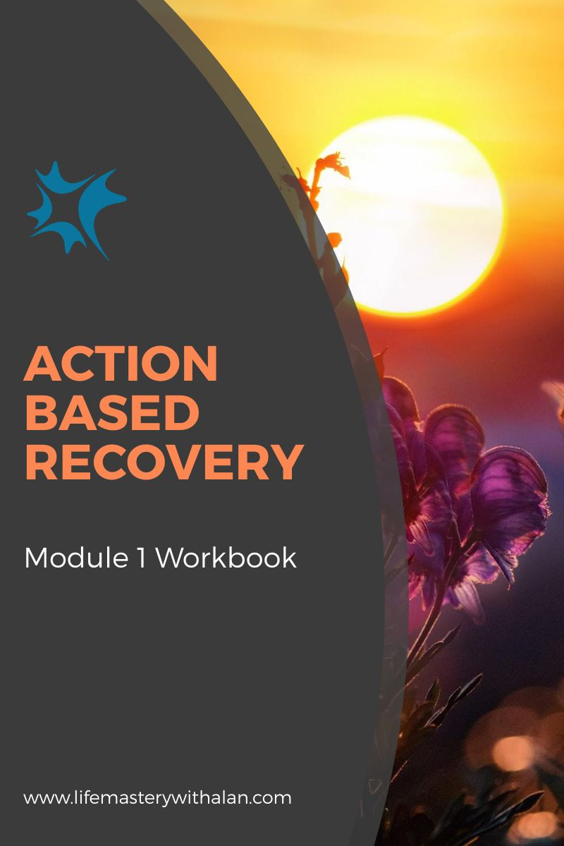

The Benefits of Self-Discipline By
www.LifeMasteryWithAlan.com

Table of Contents
Introduction 2
Get Clear 3
Financial Goal 3
Career Goal 3
Family/Relationship Goal 4
Health/Fitness Goal 4
Personal Development Goal 4
Find Your Why 5
Prepare For Everything 6
Plan & Prioritize 9
Measure Your Progress 12
Stay The Course 13
Find an Accountability Partner 14
Rewards 14
Conclusion 16

Introduction

Self-Discipline can be scary. Especially when it is related to change.

It can make you feel limited or like you are locked in a cage. You may think you cannot have what you want and you have to do things you are not sure you can do. Like having a life with peace of mind during recovery.

It is possible and you can do it. Although initial abstinence is usually challenging ongoing recovery can help you to develop a life worth living. A life you truly deserve.

Self-Discipline is not about limitations. It is about having guidelines that will help you move towards having the life you have always wanted and dreamt about experiencing.

It gives you freedom from the effects of addiction and access to your true self. Tapping into the power of self-discipline means you are free from the whims of your emotions and self-destructive habits. It helps propel you towards accomplishing your goals and having a life that you may not have thought was even possible.

Far from being scary, self-discipline is something to embrace and to strive toward daily. It gives you the structure to have true freedom i.e., the freedom to choose.

As you use this workbook you are going to learn how to embrace true freedom. The kind of freedom to do the things you want and that will help your recovery efforts be successful. By building your self-discipline through simple, actionable steps, you will finally be able to live the kind of life you want and deserve.

Your initial step towards true freedom awaits you on the next page.

Get Clear

One of the first steps towards self-discipline is being clear about exactly what you want. Once you know this you will have a goal to work towards. Your goals will serve as a road map and can motivate you to maintain your self-discipline.

One of the best ways to figure out what you want is to create a vision of the life you want to live. Then identify the goals that will help you to get there. Imagine one vision for each of the different life areas you want to change.

Imagine the details of each vision and write your goals and the details of each vision in your workbook. Be as detailed as possible without stressing yourself. If you do not have room in the workbook use a notepad.

And do not concern yourself with how possible it is for you to live your vision. You do have circumstances, but your circumstances do not have you.

Set one goal for each of the following areas of your life:

Financial Goal
____________________________________________________________________________________________________________________________________________________________________________________________________________________________________________________________________________

Career Goal
____________________________________________________________________________________________________________________________________________________________________________________________________________________________________________________________________________

Family/Relationship Goal
____________________________________________________________________________________________________________________________________________________________________________________________________________________________________________________________________________

Health/Fitness Goal
____________________________________________________________________________________________________________________________________________________________________________________________________________________________________________________________________________

Personal Development Goal
____________________________________________________________________________________________________________________________________________________________________________________________________________________________________________________________________________

Once you have set a goal in each area move on to the next section.

Find Your Why

Now that you have your visions and goals this next step is vitally important. Think about each of your goals and jot down why each one is important to you.

Setting the goals created your chosen destination and this exercise will be your fuel to get there.

Knowing why you want something is a key to staying motivated to practice self-discipline.

WHY DO YOU WANT TO ACHIEVE THESE GOALS
Financial | Career | Family | Health | Personal

Prepare For Everything

Now you have some goals and have clearly stated why they are important to you. That is a big step! Now it is time to do a little preparation.

When it comes to self-discipline there are two possible major issues related to maintaining consistency: obstacles and distractions. An unexpected obstacle can stop you right in your tracks and contribute to you becoming undisciplined. Also distractions surround us constantly and they can interfere with your commitment.

You cannot possibly predict every obstacle or distraction, but you can brainstorm some potential ones – and prepare on how to deal with them.

In this section you will brainstorm obstacles and distractions for each of your goals. Then you will take some time to formulate a plan on how to deal with or eliminate them much like you would in making a relapse prevention plan.

Financial Obstacles & Distractions

How I Can Deal With Them

Career Obstacles & Distractions

How I Can Deal With Them

Family Obstacles & Distractions

How I Can Deal With Them

Health Obstacles & Distractions

How I Can Deal With Them

Personal Obstacles & Distractions

How I Can Deal With Them

Plan & Prioritize

If you want to lead a self-disciplined life then planning and prioritizing is key.

Using the goals you set from above jot down 5 actionable steps that you can take towards them now. Instead of jotting down 5 steps randomly it would be best if you prioritize them from 1-5 (1 being the highest priority).

This step will help your self-discipline in two ways. First, you will have a list of steps to focus on. As you are working on those steps then you will be practicing self-discipline. Secondly since these steps are ranked in importance you know exactly what you will and will not be working on at any given time.

Knowing and actively pursuing your goals is self-discipline in action.

Financial Goal Actionable Steps:

1.

2.

3.

4.

5.

Career Goal Actionable Steps:

1.

2.

3.

4.

5.

Family Goal Actionable Steps:

1.

2.

3.

4.

5.

Health Goal Actionable Steps:

1.

2.

3.

4.

5.

Personal Goal Actionable Steps:

1.

2.

3.

4.

5.

Measure Your Progress

After completing the last section you have about 25 actionable steps you can take towards accomplishing the things you want.

One way to help yourself stay on track (i.e. disciplined) is to figure out a way to measure your progress. If you have decided to be abstinent from the use of drugs and/or alcohol you will have met your goal after you have stopped using. You may then set a second goal of how long you want to stay abstinent.

With some goals you may need to identify a series of steps that will help you measure your progress. For example, if you are not sure if you want to stop smoking cigarettes instead of immediate total abstinence you can identify how many less cigarettes than usual you will smoke in a day or week.

Using a notebook or an app like Evernote create a new page for each of your goals to track the following things:

Your Goal (this is the original goal you set)
Your Steps (these are the actionable steps you set)
Deadline (set a timeline for each actionable step)
Successes (keep track of all of your successes along the way for motivation)
Challenges (keep track of your challenges and obstacles as learning material)

Set up a page like that for each goal you set in this workbook or outside of it.

This will help to keep you focused on your goals and accomplishments.

All of that is KEY to staying disciplined.

Stay The Course

You have done an incredible job so far. You are on your way or you have actually created your map to a new self-disciplined life.

The key now is to stay focused. You will achieve that in two ways: accountability and rewards.

There is an almost universal truth about us as people: We are less likely to let someone else down than ourselves and we react positively to rewards.

So here are 2 very simple yet powerful steps to take.

Find an Accountability Partner and/or a Sponsor

My accountability partner/sponsor will be: _________________________

Your accountability partner/sponsor should be someone who truly cares about you. If you are not ready to have a regular sponsor ask someone if he/she is willing to be your temporary sponsor. You will tell this person your goals and then meet up (in person, phone or skype) to check in every once in a while. In case you do not know it is best that your sponsor be the same gender as you.

Rewards

The idea here is to think about a reward you will give yourself when you reach each of your goals. Having this reward is an added motivator towards reaching your goals. If things get challenging you might use the idea of the reward to motivate yourself.

Financial Goal Reward:

Career Goal Reward:

Family Goal Reward:

Health Goal Reward:

Personal Development Goal Reward:

Conclusion

Congratulations! You have taken a huge step towards a new disciplined version of yourself.

You might have gone into this thinking self-discipline was boring, limiting or a huge pain in general – but I hope this workbook put you at ease.

Essentially all you have done here is map out exactly what you want in life and how to get there. You even tossed in some rewards along the way. Is there anything scary about that? If your journey becomes challenging remember the Serenity Prayer.
As you stay the course and reach your goals, you will realize that self-discipline is not a self-imposed jail cell – it is actually quite freeing.

Wishing you the best always!
Alan Simberg

